
The med report of “Database Design & Development ”

- Student name: omar Abuhassan
- student ID Number: 22110264
- Major: Data Science and Artificial Intelligence
- Academic Year: 2nd

- Course Tutor: Dr. Samer Suleiman
1.Database Requirements:
1.1:scenario
In the bustling environment of the library system, Abuhassan, a fresh face to the library community, completes his registration, prompting the efficient staff to establish a dedicated member record for him. In pursuit of literary treasures, Omar searches for "The Great Gatsby" and successfully checks out the book, initiating the creation of a transaction record. Omar subsequently navigates the system to review his borrowed books, with "The Great Gatsby" prominently featured. Upon returning the book, its status is promptly updated. Meanwhile, encountering an unavailable copy, Jane Smith places a reservation. The library staff enhances the collection with the introduction of the new book, "To Kill a Mockingbird." Users like Omar have the opportunity to delve into author details, such as those of F. Scott Fitzgerald. Proactive staff members generate analytical reports and make profile updates, with Alice, for example, ascending to the role of "Senior Librarian." Seamless access to section location details assists users, including Omar, in locating specific sections like Science Fiction. This dynamic narrative encapsulates the spectrum of member interactions, book transactions, staff management, and information retrieval, offering a comprehensive glimpse into the multifaceted functionalities of the library database system within the context of Abuhassan’ s library experience.

1.2: Data Requirements
The library contains several sections, each one has name(category),ID and location. Each section offers one or more books it has title ,ID ,category and genres. that was written by one or more authors each author has ID ,age ,name ,birthday ,nationality.
The library has many members. Each one has an ID, name, phone, age, states, every one of them can make just one transaction at the same time each one must contain ID, member ID, book ID, date, fines.
Each section has some staff, each one has an ID, SSN, name, phone number, role, salary.
The database of the library helps the members so that they can see the library sections and all the books in that section and also helps the staff so that they can find out the location of the books and the number of available books if one of the members asks about them.

1.3 :User and System Requirements
- User Requirements:
- User Authentication and Authorization
Users should have the ability to sign in using their login information. Various user roles, such as librarians and members should have varying levels of access privileges.
- Book Management:
Users should have the capability to search for books based on their title, author, or genre. The information provided about a book should encompass its title, author, genre, ISBN number and current availability status.
Members should be able to view their borrowed and reserved books.
- Author Information:
Users should be able to search for authors and view their works.
Author information should include name, biography, and a list of associated books.
- Member Services:
Members should be able to register and update their profile.
The system should track members' borrowing history and due dates.
- Transaction History:
The system should be able to maintain a record of all transactions, such, as checkouts, returns and reservations. Users should have the option to access and review their transaction history.
- Staff Management
Staff should be able to manage book inventory, add new books, and update book information.
The system should support the addition and removal of staff members.
- Section and Section Location:
Books ought to be categorized into sections. Each section should have a specific place assigned to it. Visitors should have the ability to explore books based on their sections or locations, within the library.
- Reporting and Analytics:
The system should provide reports on popular books, overdue books, and transaction summaries.
Staff should have access to analytics for inventory management.

- System Requirements:
- Database Design:
The system should have tables for book, author, member, transaction, staff, section, and section location.
Relationships between tables should be appropriately defined (e.g., foreign keys).
- Scalability:
The database should be designed to handle a growing number of books, members, and transactions.
- Data Integrity:
Implement data validation to ensure accurate and consistent information.
Enforce constraints to prevent data anomalies.
- User Interface:
Create a user interface that's intuitive and user-friendly enabling users to navigate and interact seamlessly.
Ensure compatibility with various devices and browsers.
- Security:
Implement secure user authentication mechanisms.
Apply role-based access control to restrict unauthorized access.
- Backup and Recovery:
Regularly back up the database to prevent data loss.
Implement a recovery plan in case of system failures.

- Performance:
Optimize database queries for efficient performance.
Monitor and manage system resources to ensure responsiveness.
- Documentation:
Provide comprehensive documentation for system users and administrators.
Include guidelines for system maintenance and troubleshooting.
- Integration:
Ensure compatibility with other systems if necessary (e.g., library catalog, external databases).

2 Database Design
2.1 Conceptual Design:
Conceptual design is a crucial phase in the construction process that plays a pivotal role in translating abstract visions into tangible blueprints that guide subsequent phases of construction . It is often likened to the compass of the construction industry, setting the direction and tone for the entirety of a project . At its core, concept design is the embryonic phase where ideas are born, shaped, and refined to meet both the aspirations and practical requirements of clients . The essence of concept design lies not only in the aesthetic appeal but also in the functionality, feasibility, and alignment with client aspirations .

The goal of conceptual design is to establish the basis of logic and ground the "why" and "how" of an artwork . It is devised to accomplish a practical objective while being aesthetically pleasing .
- Goals of Conceptual Design include:
Clarifying the problem
Understanding the user and their needs
Defining the problem statement
Identifying the constraints
Breaking down the problem into sub-problems.
- Components of conceptual design:
Boxes: Denote entities
The lines: denote relationships between entities

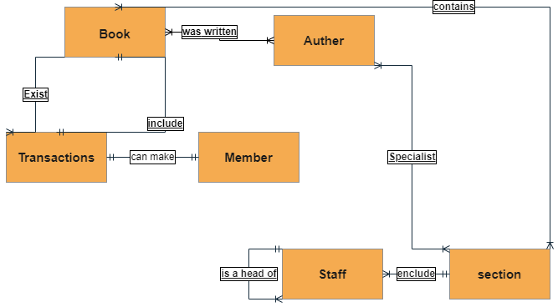

In this conceptual design, I put the relationship between entities in a simple and clear way for all people, even if someone is unfamiliar with computer science or even databases.

2.2 Schema and Mapping
Book (id, title, category ,genres )
Book author (book id, author id)
Book section(book id, section number)
author (id, age , fist name, last name, nationality)
member (id, first name, last name, states ,age)
member phone (member id, phone)
transaction ( id, member id, book id, type)
transaction dates (id, date of the metaphor, Return date, fine)
staff (id, first name, last name, SSN, role, salary, head id)
staff phone (staff id, staff SSN, phone)
section (category, number, head id)
The strong entity is arrived in blue
The week entity is arrived in red
Evry primary key is underlined
Every foreign key is arrived in yellow

staff section (staff id, staff SSN, section number)
section location (section number, location)

2.4 Logical Design:
The logical design phase plays a role in the process of designing a database. During this phase the conceptual design is transformed into a format that can be effectively implemented using a database management system. It entails converting the schema, which outlines the structure and relationships between data elements into a schema that complies with the rules and constraints of the selected database management system. The logical schema acts as a blueprint for organizing the database structure and serves as a basis for the following design stage.
- The goal of logical design
is to create a database schema that is optimized for the data model and the queries that will be executed on the database.
- Components of logical design:
Table : Clarifies and shows each entity and its attributes and show the primary , foreign keys.
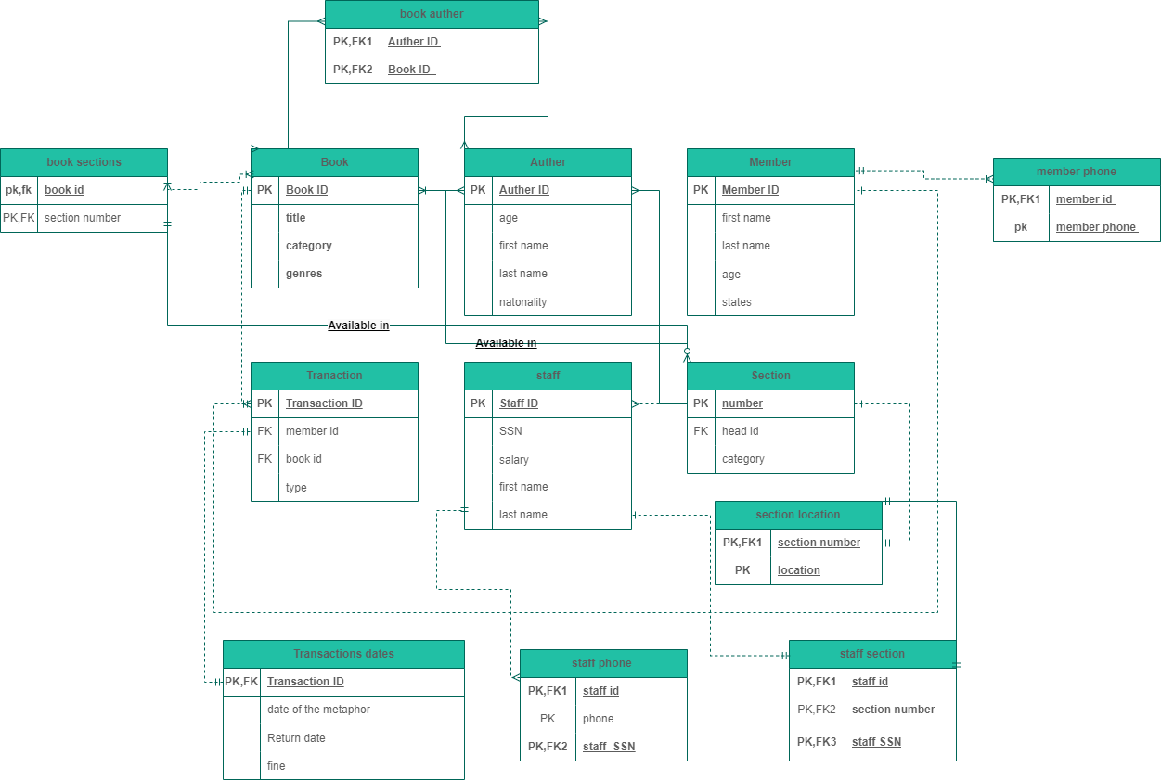
Lines : denote relationships between entities and show the strong , week relationships.

This logical design shows each entity and its features in a simple and clear way that can be understood by people who do not study it.
2.5 Physical Design
Physical design is a crucial phase in the database design process that involves translating the logical design into a schema that can be implemented in a database management system . It is the process of defining the physical layout of the database, including the storage structures, access methods, data type and physical constraints .
- The goal of physical design
is to create a database schema that is optimized for performance and storage efficiency .
- Components of physical design:
Table : Clarifies and shows each entity and its attributes and show the primary , foreign keys, data type and physical constraints.
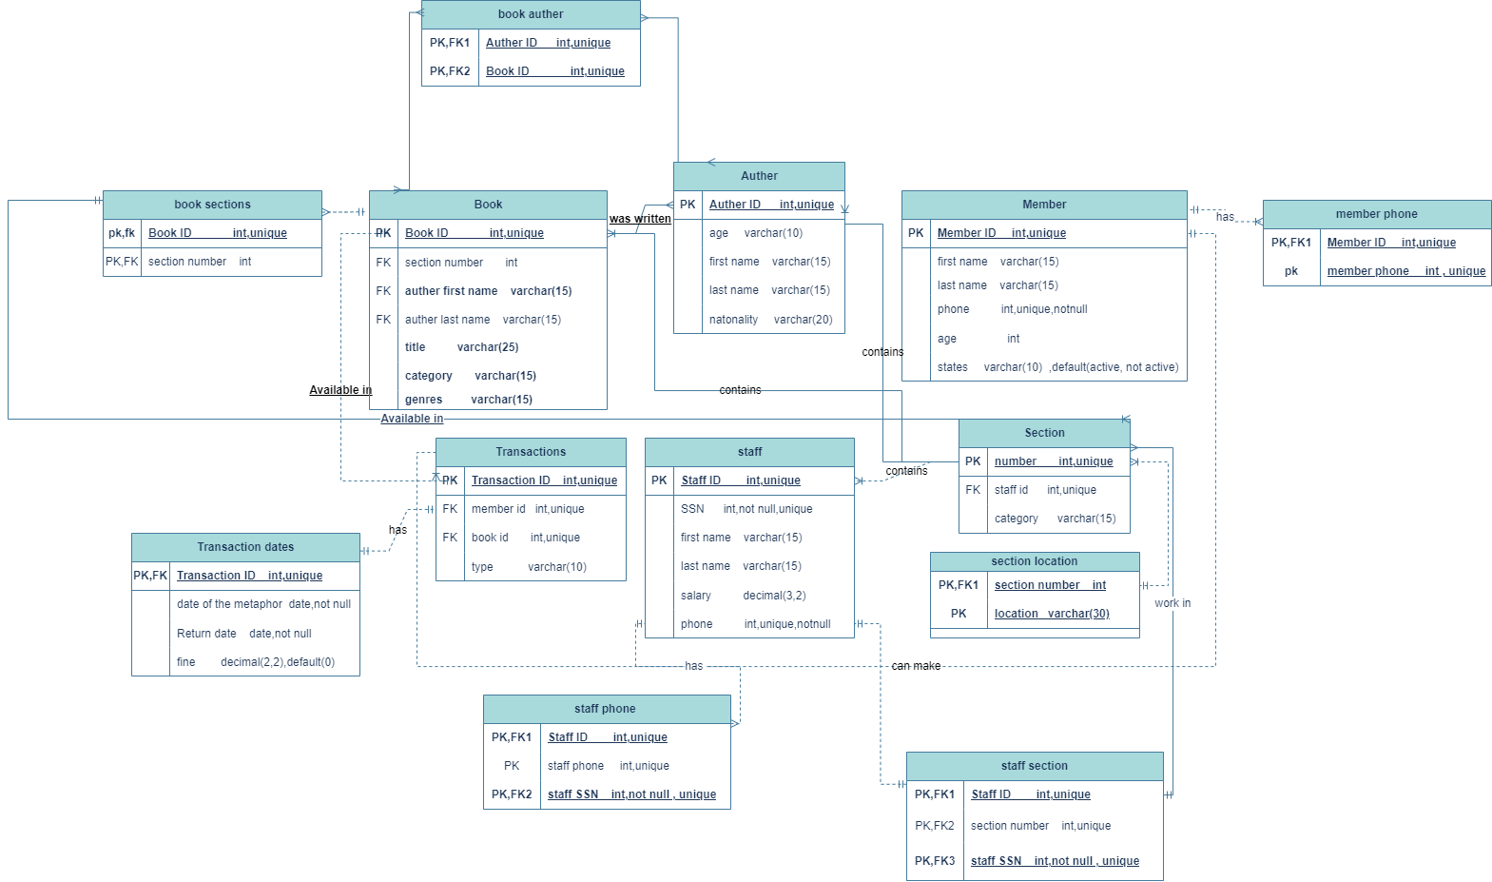
Lines : denote relationships between entities and show the strong , week relationships.

This physical design shows each entity and its features whit data type and physical constraints in a simple and clear way that can be understood by people who do not study it.
2.3 Normalization
2.3.1 1st NF
A process whose competence is to reduce as many repetitions as possible so that the attribute with the multi value is deleted and the composite values are divided.
Relations | Attributes | Violation Description | Solution – Relations
staff (id, name, phone, ssn, role, section num, head id) | name | The name is composite attribute | staff (id, first name, last name, phone, ssn, role, section num, head id)
staff (id, name, phone, ssn, role, section num, head id) | phone | The phone is multi value attribute | staff (id, name, ssn, role, section num, head id)  staff phone(staff id, phone)

2.3.2 2nd NF
This stage is concerned with full and partial dependency.
Relations | Attributes | Violation Description | Solution – Relations
Book (id, title, category, genres, author id, author first name, author last name, section number) | id(title, category, genres, section number)  author id( author first name, author last name) | The non-prime attributes (title, category, genres  Section number) depend on a part of the pk which is ID.  And the non-prime attributes (author first name, author last name) depend on a part of the key which is author id.  So, we have partial dependencies | book(id, title, category, genres  Section number)  Author (id, author first name, author last name)
Staff(id, salary, role , section number, section location) | id(salary, role)  section number (section location) | The non-prime attributes (salary, role) Depend on a part of the pk which is ID.  And the non-prime attribute (section location) depends on a part of the key which is section number.  So, we have partial dependencies | Staff(id, salary, role)  Section(section number, section location)

2.3.3 3rd NF
This stage is concerned with transitive dependencies.
Relations | Attributes | Violation Description | Solution – Relations
Book (id, title, category, genres, author id, author first name, author last name, age) | Book idauthor id  Autor id( author first name, author last name, age)  Book id( author first name, author last name, age) | The PK (book id) can determine any attribute in the table including AuthorID. At the same time, the AuthoriD determine first name, Last name, and age. As Author ld. is not a candidate here, we have a transitive dependency. | book(id, title, category, genres  author id)  Author (id, author first name, author last name, age)
Staff(id, salary, role, section number, section location, section category) | Staff id section number  section number (section location section category) | The PK (staff ID) can determine any attribute in the table including section number. At the same time, the section number determine section location and section category. As section number is not a candidate here, we have a transitive dependency. | Staff(id, salary, role, section number)  section number (section location, section category)

2.6 Effectiveness of the Design
In the beginning, there is no library that does not contain books and the absence of authors means there are no books, and any library that does not contain transactions, how can the operations performed by library members be done without the presence of staff, and how can a library be without sections where books of the same subject are placed together.
- Book:
The title is the introduction of the book, as they said, the book is clear from its title and how the book can appear without a publishing house to publish it, and the book must be of a certain category in order to be classified.
- Author:
There are many authors in the world, and because history does not mention names, we must know the name of the author and we must know his date of birth or age at least so that we know the era in which he wrote and about its conditions and know his nationality so that we know the conditions of that country that we may not have heard of before.
- Member:
Because the convenience of our library members is our goal, we must get his name in order to associate him with a special number so that he is distinguished from others( ID) and get his phone number so that we stay in constant communication.
- Transaction:
In order for our office to be organized, we have given each transaction an ID and we have added a book ID and a member ID so that things are highly organized and for each transaction there is a start and end date.
- Staff:
Each staff has a special ID that has been linked to his SSN directly and his SSN is linked to his name and each employee has only one job inside the library and based on that he is given a salary.
- Section:
The library is divided into several sections, each section has a distinctive number and a specific location, and each section contains only one category of books.
Relationships:
- Book: Author (M:N):
In my opinion, one writer can have more than one author and one author can have more than one work (Book).
- Book : section (M:N):
Our library is full of books so one section contains a lot of books and one book can be of more than one category so it can be in more than one section.
- Author : section (M:N):
The world has a lot of brilliant authors with many specialties, so it can be for one author to have his works in more than one section.
- Book : Transaction (1:1):
Each transaction can only contain one book, and the same book cannot be present in more than one transaction.
- Transaction : member (1:1):
A single transaction can only be made by one member and one member cannot perform more than one transaction at the same time.
- Staff: section (1:1) :
One department contains more than one staff, but a staff cannot be present in more than one department.
- Staff : Staff (M:N):
In each section there is a staff who is responsible for several staff.
Conceptual Design:
After reviewing the data, I mentioned above, I decided that the conceptual design should be in this form, and this design is useful for easy clarification of entities and relationships among them.
Schema:
The importance of the schema lies in the fact that it is the basic building block for building all designs and because it contains all entities and all attributes and primary and foreign keys, it can be understood by all simple people.
Logical design:
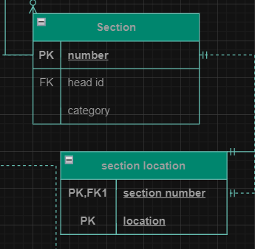
In the logical design, we indicate the entities and attribute Some of them can be a primary key and some of them can be foreign of each of them in the form of a table and connect them with lines representing the relationships that were explained in the conceptual design, with some modifications, including that the line can be a section to indicate that the relationship between the two entities is weak and if it is connected, the relationship is strong It also helps in building physical design, so it is a key and crucial point in building databases.
Physical design:
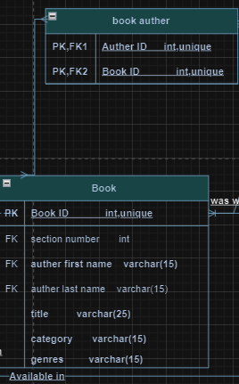
In the physical design, we indicate the entities and attribute With the addition of the data type and component for each of them Some of them can be a primary key and some of them can be foreign of each of them in the form of a table and connect them with lines representing the relationships that were explained in the conceptual design, with some modifications, including that the line can be a section to indicate that the relationship between the two entities is weak and if it is connected, so it is a key and crucial point in building databases.

Normalization :
- First form:
This step is useful for preserving information and reducing as much redundancy as possible, ensures data structuring, facilitates operations and is based on deleting all attributes that may contain multi value data and splitting the composite attribute.
staff (id, name, phone, ssn, role, section num, head id) | name | The name is composite attribute | staff (id, first name, last name, phone, ssn, role, section num, head id)

- second form:
It generally helps to reduce redundant data stored in memory, gets rid of partial and complete consequences, and activates new tables to reduce the amount of duplicate data.

Staff(id, salary, role , section number, section location) | id(salary, role)  section number (section location) | The non-prime attributes (salary, role) Depend on a part of the pk which is ID.  And the non-prime attribute (section location) depends on a part of the key which is section number.  So, we have partial dependencies | Staff(id, salary, role)  Section(section number, section location)

- Third form:
It is a database schema design approach for relational databases that uses Normalization Principles to reduce data duplication, avoid anomalies in the data, ensure referential integrity , and simplify data management

Book (id, title, category, genres, author id, author first name, author last name, age) | Book idauthor id  Autor id( author first name, author last name, age)  Book id( author first name, author last na (Anon., n.d.) (Anon., n.d.) (Anon., n.d.)me, age) | The PK (book id) can determine any attribute in the table including AuthorID. At the same time, the AuthoriD determine first name, Last name, and age. As Author ld. is not a candidate here, we have a transitive dependency. | book(id, title, category, genres  author id)  Author (id, author first name, author last name, age)

Conclusion:
To summarize all of the above, working on the steps facilitates the work and helps to clarify and clarify it for anyone who can complete the work and is also useful to refer to them in the event of any error in the database or avoid any error.

References
Anon., n.d. geeksforgeeks. [Online]
Available at: https://www.geeksforgeeks.org/third-normal-form-3nf/
Anon., n.d. stackexchange. [Online]
Available at: https://dba.stackexchange.com/questions/26933/first-normal-form-why-is-it-good-and-how-does-it-reduce-redundancy
Anon., n.d. tutorialspoint. [Online]
Available at: https://www.tutorialspoint.com/Second-Normal-Form-2NF

